Industrial Ethernet Switch Card (IES)

Hardware Design Document (HDD)

Revision B

Ownership Disclaimer
This document contains proprietary and confidential material that is the sole property of Compressor Controls Corporation. The information contained herein is intended for internal use by Compressor Controls Corporation employees and is not intended for distribution outside of the company. As an unpublished work of trade secrets, the recipient shall keep this document confidential. Any re-use, copying, or distribution, either in whole or in part, of this material without the express written consent of Compressor Controls Corporation is strictly forbidden.
Copyright © 2013 by Compressor Controls Corporation. All rights reserved.
Revision History

Revision | Date | Description | Author
B | 29-Apr-13 | First Release | Muthuvelu.D

Approvals

Product Manager Date

Table of Contents

1 Introduction 5
1.1 Purpose 5
1.2 Audience 5
1.3 Scope 5
2 General Description 6
2.1 Board Features 6
2.2 Implementation Block Diagram 7
3 Description of Functional Blocks 7
3.1 EtherCAT Slave Controller 7
3.2 EtherCAT Master Interface 8
3.3 IOP card interfaces 9
3.4 RJ45 Expansion Interface 10
3.5 High Speed Differential Mux 10
3.6 I2C to I/O expander interface 11
3.7 Hot Swap Control 11
3.8 LOAD SHARING 12
3.9 Power 12
3.10 MICROCONTROLLER 12
3.11 Debug Support 13
3.12 Front Panel LEDs 13
4 Schematic Design 14
4.1 Design Tool 14
5 Board Layout Design 14
5.1 Board Thickness 14
5.2 Board Stack-up 14

Introduction

Purpose
The objective of this document is to describe the hardware design of Industrial Ethernet Switch Card (IES Card).

Audience
This document is targeted at Personnel involved in development and testing of board at Mindteck as well as CCC.

Scope
The scope of this document is to describe IES card hardware design in brief. The document details the various functional level block diagrams. Also this document details about the board power budget analysis, any kind of mathematical / simulation analysis.

General Description

Board Features

Sl. No. | Feature | Description
1 | EtherCAT Slave Controllers | Seven EtherCAT slave interfaces using ET1100Beckhoff
2 | Ethernet PHYs | Two 10/100 Ethernet PHY interfaces on board to support MII
3 | I2C | An EEPROM interfaced for each ET1100 to store configuration data using I2C and an I2C to I/O expander interface
4 | Hot-swap Control | Hot-swap implemented using LT4210
5 | Power Supply | 6.5V to 3.3V conversion using TPS54331
6 | Multiplexer | High speed differential Mux ADG774A is used to multiplex between APP and RJ45 MDI signals
7 | Microcontroller | Freescale MPC5534 208 PIN BGA
8 | LOAD SHARING | LTC4370I

Implementation Block Diagram

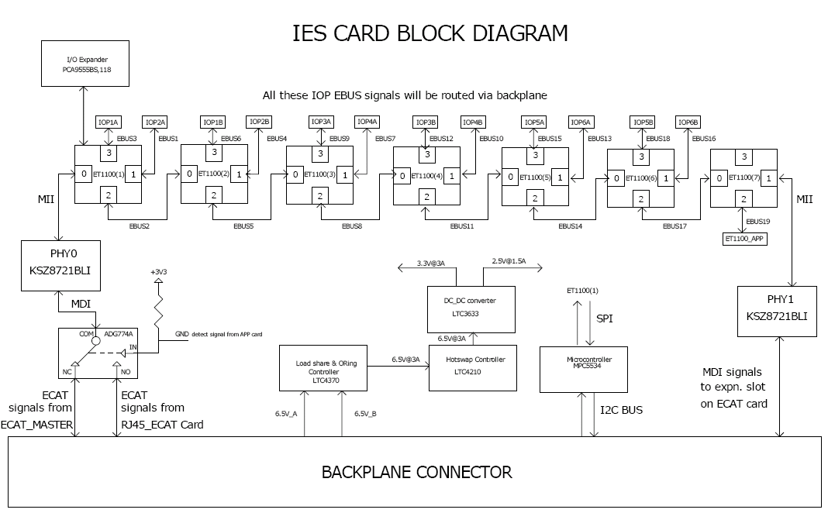

Description of Functional Blocks

EtherCAT Slave Controller
ET1100 from Beckhoff is used as ECAT slave controller. An EtherCAT Slave Controller (ESC) takes care of the EtherCAT communication as an interface between the EtherCAT fieldbus and the slave application. The EtherCAT interfaces or ports connect the ESC to other EtherCAT slaves and the master. The MAC layer is integral part of the ESC. The physical layer may be Ethernet or EBUS. The physical layer for EBUS is fully integrated into the ASICs. For Ethernet ports, external Ethernet PHYs connect to the MII/RMII ports of the ESC. Transmission speed for EtherCAT is fixed to 100 Mbit/s with Full Duplex communication. Link state and communication status are reported to the Monitoring device. EtherCAT slaves support 2-4 ports; the logical ports are numbered 0-1-2-3.

MII ports are always assigned to the lower physical ports, then EBUS ports.
If any MII ports are configured, the lowest logical MII port is always connected to physical port 0, the next higher logical MII port is connected to physical port1, and so on..

The key features include

• Ports: 2-4(each EBUS/MII)
• FMMUs: 8
• Sync Managers: 8
• RAM [Kbyte]: 8
• Distributed Clocks: 64bit
Process Data Interfaces
• Digital I/O: 32bit
• SPI Slave: Yes
• 8/16 bit μController: Async/Sync

The core voltage needed (2.5V) for the ESCs is generated using the internal regulator of the ESCs from its I/O voltage (3.3V).

EtherCAT Master Interface
EtherCAT master (P1021 processor an APP card) interface is implemented using MII physical layer, port 0 of ET1100 (1). The MDI signals (TX+/- and RX+/-) from APP are routed via backplane connector. ET1100 needs 25MHz crystal for its operation. A 25MHz TCXO (Temperature Compensated Crystal Oscillator that compensates for temperature variations, to maintain a more constant frequency) is used for ET1100 (1). The remaining six ET1100s use 25MHz crystals. All the ESCs use a separate 16KBit EEPROM that is connected to ET1100 on its local I2C bus. These EEPROMs are used to store power on configuration of ESCs.

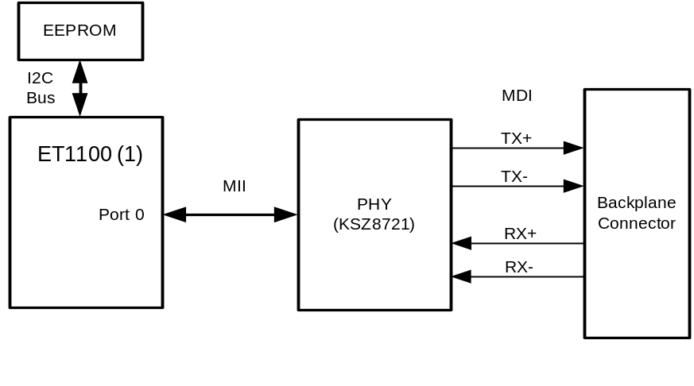

Below are the MII signals from the Phy that are interfaced to ET1000
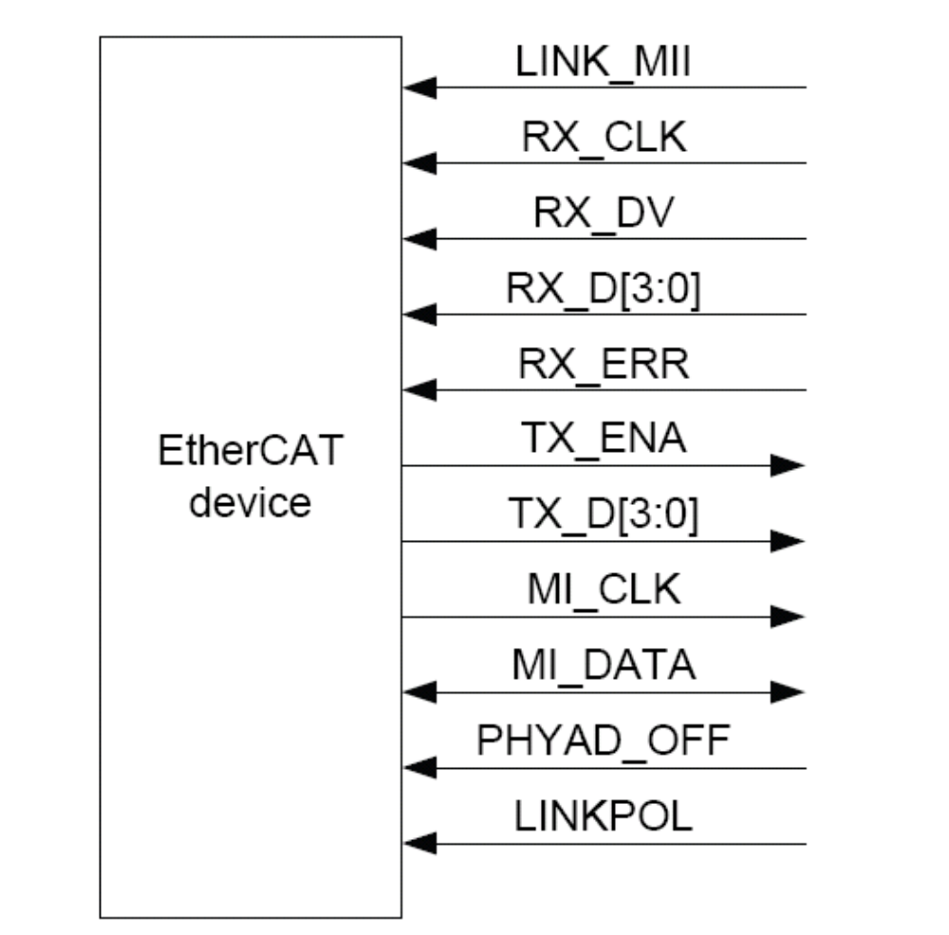

IOP card interfaces
IN each NGP system there are 12 IOP (Analog or Digital In/Out Processor) cards that are interfaced to APP master processor via IES card. IES card directs the EtherCAT data that is received on Port 0 of ET1100 (1) to the designated EtherCAT slaves/IOP cards through the EtherCAT protocol. All the IOP cards are interfaced to ESCs on their EBUS physical layer. Below diagram shows how an IOP is connected to an ESC.
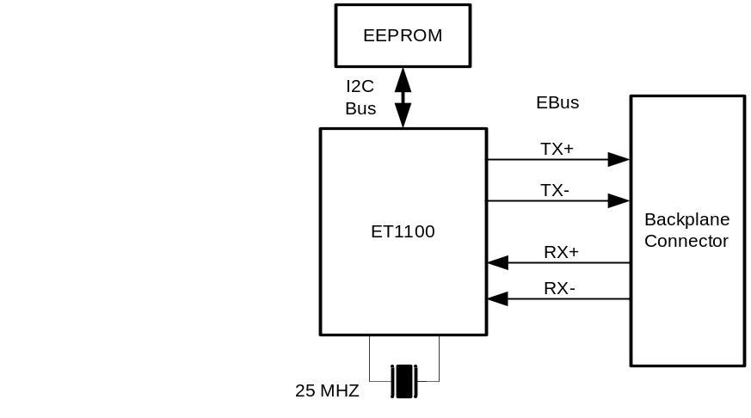
Termination with an impedance of 100 Ω between EBUS-RX+ and EBUS-RX- is provided for EBUS ports close to ET1100 pins. Below table lists the corresponding LVDS EBUS signals that connect to appropriate IOPs

IOP Card Name | EBUS Number | ESC logical Port number
IOP 1A | EBUS 3 | Port 3 of ET1100(1)
IOP 2A | EBUS 1 | Port 1 of ET1100(1)
IOP 1B | EBUS 6 | Port 3 of ET1100(2)
IOP 2B | EBUS 4 | Port 1 of ET1100(2)
IOP 3A | EBUS 9 | Port 3 of ET1100(3)
IOP 4A | EBUS 7 | Port 1 of ET1100(3)
IOP 3B | EBUS 12 | Port 3 of ET1100(4)
IOP 4B | EBUS 10 | Port 1 of ET1100(4)
IOP 5A | EBUS 15 | Port 3 of ET1100(5)
IOP 6A | EBUS 13 | Port 1 of ET1100(5)
IOP 5B | EBUS 18 | Port 3 of ET1100(6)
IOP 6B | EBUS 16 | Port 1 of ET1100(6)
Peer APP card is connected via EBUS 19 of ET1000 (7).

RJ45 Expansion Interface
An external RJ45 EtherCAT slave interface is implemented using MII physical layer on logical port 1 of ET1100 (7). On board magnetic is provided near the connector for isolation. This RJ45 connector is present on ECAT card and the signals are routed via backplane.

High Speed Differential Mux
NGP system will have multiple chassis cascaded. In case of main chassis APP card is the ECAT master, and in case of extended chassis ECAT data from external RJ45 will be fed as input to IES card and APP will not be present. To address this scenario, a multiplexer IC ADG774A is used to select the input between APP and RJ45. The schematics implementation is shown below.

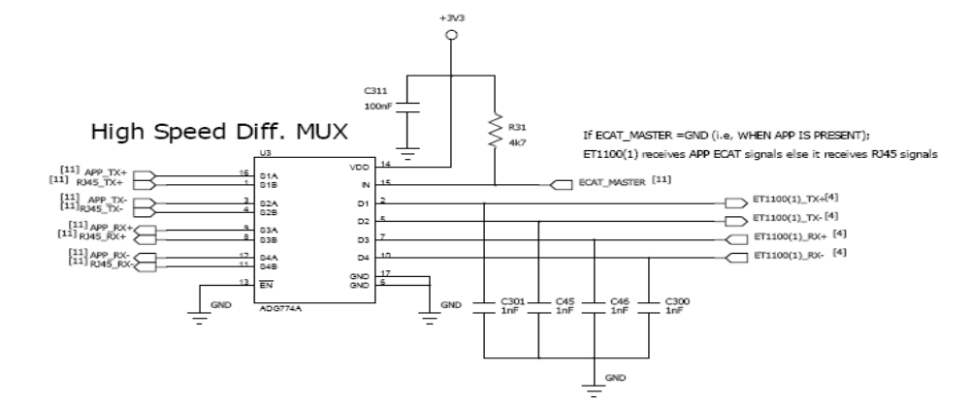

I2C to I/O expander interface
For debugging purpose in case if EtherCAT fails to work, I2C to 8 bit I/O expander is implemented between APP Processor and ET1100(1).

Hot Swap Control
A hot-swap circuit is used to make this board ready for live insertion and removal in the system. This circuit is enabled only when it is inserted properly in the backplane by using short pin of the backplane connector.

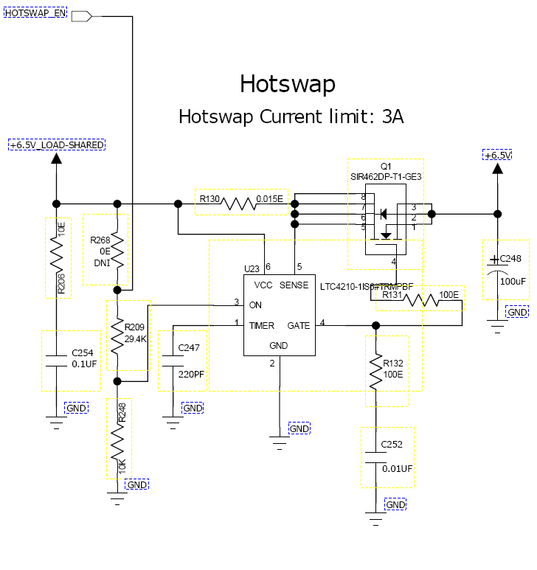

LOAD SHARING
Implemented power supply sharing (6.5V A and B) using LTC4370IMS
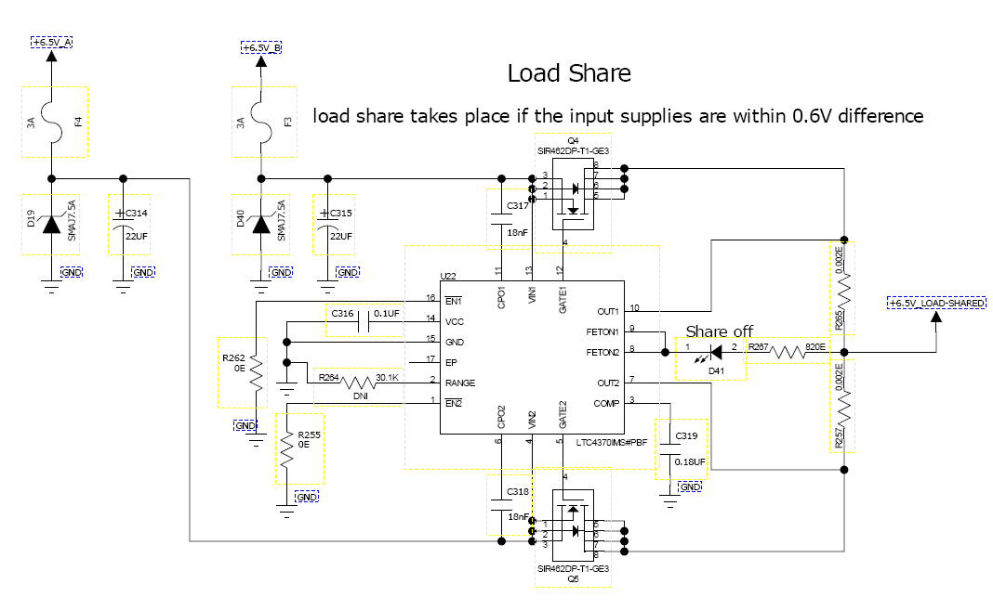

Power
ESCs used on board require 3.3V and 2.5V supply voltage; a dual output switching regulator LTC3633 from linear technology is used.

MICROCONTROLLER
Freescale MPC5534 microcontroller (208pin BGA) shall be implemented for power monitoring through I2C interface between PCC cards

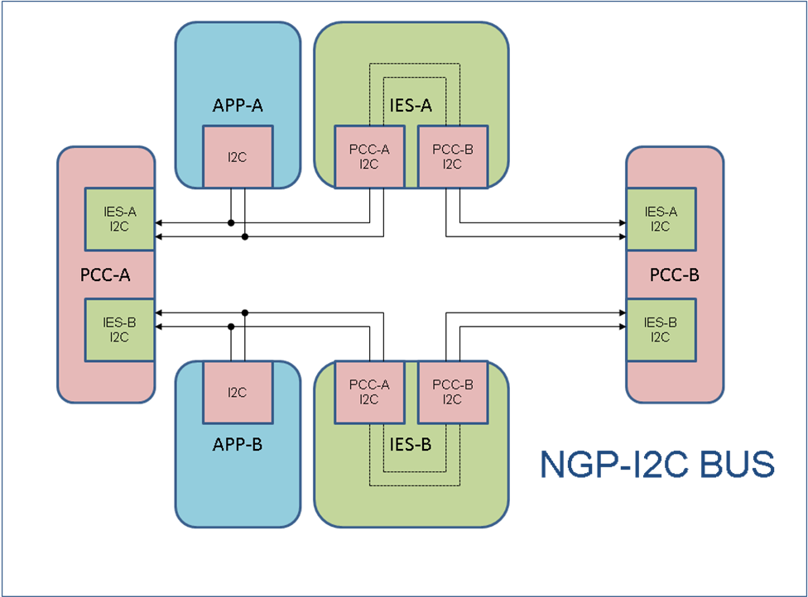

Debug Support

Debug LEDs

There are Link/Activity LEDs provided to help debugging of the board.

Test Points/ Jumpers

Test points are provided for probing important signals, power and ground nets during debugging/ testing.

Front Panel LEDs
Table below describes the LEDs used on front panel

Name |  | Function |  | Color
POWER |  | Power Supply(ies) status ok |  | Blue-CCC
ALARM |  | Card has a detectable non-critical issue |  | Yellow
FAULT |  | Card has a critical error |  | Red
IOP 1A |  | Indicates the Link/activity status for IOP 1A card |  | Green
IOP 1B |  | Indicates the Link/activity status for IOP 1B card |  | Green
IOP 2A |  | Indicates the Link/activity status for IOP 2A card |  | Green
IOP 2B |  | Indicates the Link/activity status for IOP 2B card |  | Green
IOP 3A |  | Indicates the Link/activity status for IOP 1A card |  | Green
IOP 3B |  | Indicates the Link/activity status for IOP 3B card ESC2 |  | Green
IOP 4A | Indicates the Link/activity status for IOP 4A card |  | Green
IOP 4B | Indicates the Link/activity status for IOP 4B card |  | Green
IOP 5A | Indicates the Link/activity status for IOP 5A card |  | Green
IOP 5b | Indicates the Link/activity status for IOP 5B card |  | Green
IOP 6A | Indicates the Link/activity status for IOP 6A card |  | Green
IOP 6B | Indicates the Link/activity status for IOP 6B card |  | Green
OUT | Indicates the Link/activity status for external RJ45 |  | Green

Schematic Design

Design Tool
Schematic entry is done PADS9.4

Board Layout Design

Board Thickness
Thickness of the Board designed is 1.6mm±10% [0.063” ± 10%]

Board Stack-up
The IES card is designed with eight layer stack-up with no blind or buried vias. Most of the components are placed top side of the board except for few discrete and an LED deriver IC which are placed on bottom.

